

**Smart Wallet App**

**Faculty:**

Mr. Muhammad Idham Khalif, S.Kom

Arranged by : Group 4

|  |  |
| --- | --- |
| 1. Fakhri Ali Halomoan Sihombing | (2120010242) |
| 2. Muhammad Zidan Satrio | (2120010105) |

**Continuing Education Program Center for Computing and Information Technology Faculty of Engineering, University of Indonesia**

**2023**

**PROJECT ON**

**Smart Wallet App**

Page 3

Batch Code : 4 ISA 2

Start Date : 2 April 2023

End Date : 17 April 2023

Name of Faculty : Muhammad Idham Khalif, S.Kom

**Group 4**

|  |  |
| --- | --- |
| 1. Fakhri Ali Halomoan Sihombing | (2120010242) |
| 2. Muhammad Zidan Satrio | (2120010105) |

This is to certify the report, titled **Smart Wallet App** embodies original work done by Fakhri Ali Halomoan Sihombing and Muhammad Zidan Satrio in fulfilling the first Java using Netbeans IDE project assignment in CCIT-FT UI.

Coordinator

Mr. Muhammad Idham Khalif, S.Kom

**CERTIFICATE**

**ACKNOWLEDGEMENT**

Praise be to the presence of Allah, SWT. who has helped us in making this project because without the pleasure of it we will not be able to make this project. we also thank to Mr. Muhammad Idham Khalif, S.Kom as our lecturer and mentor in making this project entitled **Smart Wallet App.**

The success and final outcome of this project required a lot of guidance and assistance from many people and we were extremely privileged to have got this all along the completion of our project. All that we have done is only due to such supervision and assistance and we would not forget to thank them. Hopefully what we have made can be useful in the future.

Best Regards,

**Authors**



A system analysis of a smart wallet app using Java that uses Phpmyadmin database involves identifying the functional and non-functional requirements of the system, such as features for transaction, payment, top up,etc.

a smart wallet app using Java and Phpmyadmin database is a complex system that requires careful analysis to ensure it meets the needs of its users. Through system analysis, we can identify the functional and non-functional requirements of the app, such as features for login username and password, registered new account , math operation, and performance. By considering these requirements, we can design and develop a reliable system that provides an enjoyable experience for user.

**System Analysis**

**Database Design**

Database design for creating a new account and login for an existing account.

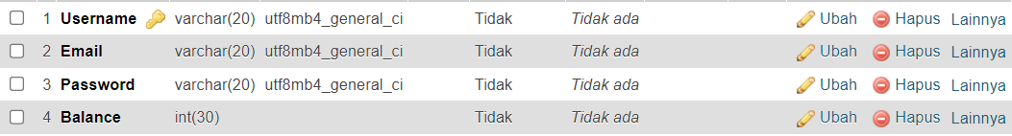

**User Interface (UI)**

Login form page, there is two (2) button including;

Login = Created account that already stored and saved on Database phpmyadmin.

Sign Up = Creating new account and then saved it into database.

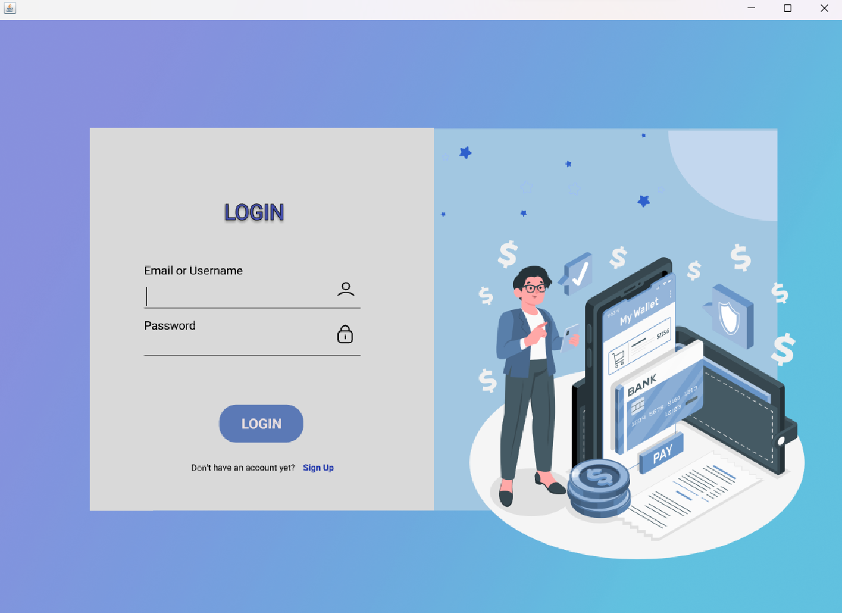

Notification that successfully connected to the database.

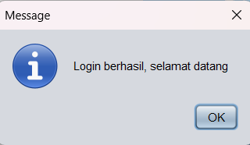

**User Interface (UI)**

Page for user create a new accounts

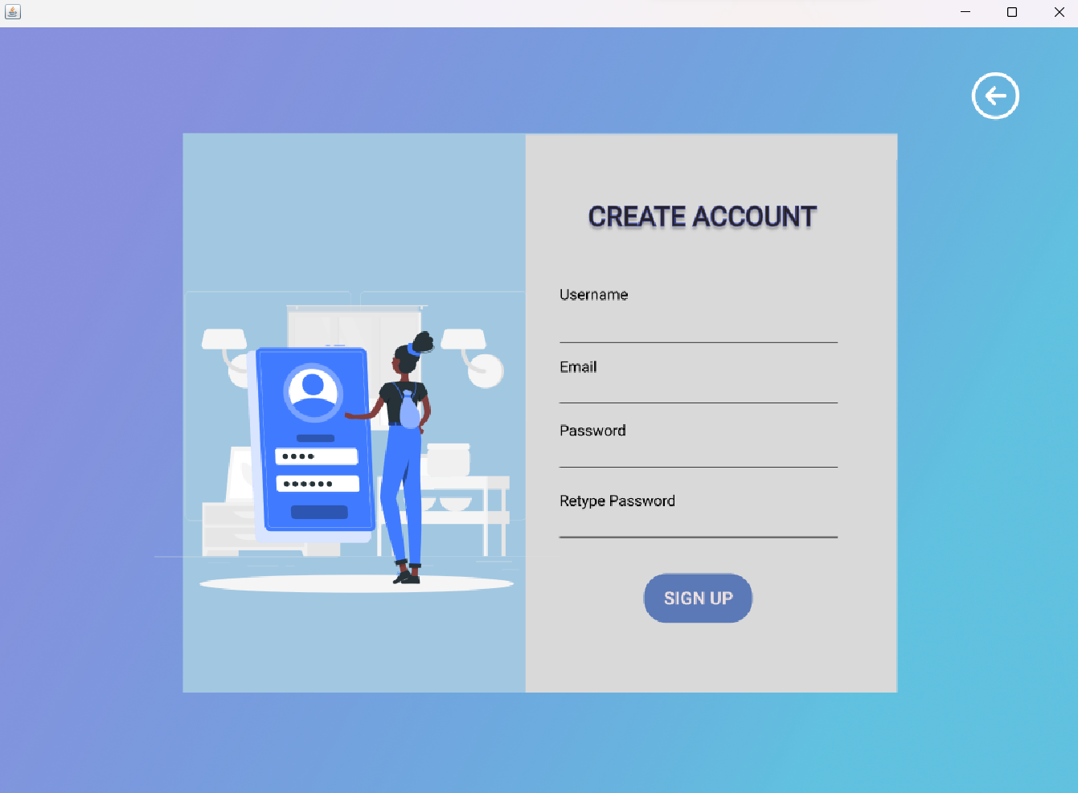

Notification that successfully created account

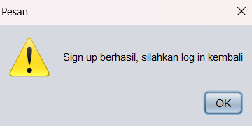

**User Interface (UI)**

Dashboard page.

Transaction Page.

**User Interface (UI)**

Top Up Page.

History Page.

**User Interface (UI)**

Last page is Account that’s show the user account.

**Sources Code Login Page**

import java.awt.FlowLayout;

import javax.swing.JApplet;

import javax.swing.JOptionPane;

import javax.swing.JTextField;

import java.sql.Connection;

import java.sql.DriverManager;

import java.sql.Statement;

import java.sql.ResultSet;

import com.mysql.cj.jdbc.Driver;

import java.awt.HeadlessException;

import java.sql.SQLException;

import javax.swing.JButton;

public class loginPage extends javax.swing.JFrame {

Connection con = null;

Statement st = null;

private String strUsername;

public loginPage() {

initComponents();

try {

Class.forName("com.mysql.cj.jdbc.Driver");

con = DriverManager.getConnection("jdbc:mysql://localhost/dbakun","root","");

st = con.createStatement();

JOptionPane.showMessageDialog(null, "Alhamdulillah Berhasil Terkoneksi");

}

catch(HeadlessException | ClassNotFoundException | SQLException ex){

JOptionPane.showMessageDialog(null,"Gagal terkoneksi Karena " + ex);

System.out.println(ex);

}

}

public void hapuslayar(){

txtInputUser.setText("");

txtInputPass.setText("");

}

public String getStrUsername() {

return strUsername;

}

public void cekAKun(){

txtInputUser.getText();

this.strUsername = txtInputUser.getText();

}

public JButton getBtnLogin() {

return btnLogin;

}

public JTextField getTxtInputUser() {

return txtInputUser;

}

String sql = ("SELECT * FROM tbldata WHERE username='"+txtInputUser.getText()+"' AND password ='"+String.valueOf(txtInputPass.getPassword())+"'");

ResultSet rs = st.executeQuery(sql);

if(rs.next()){

//this.dispose();

this.dispose();

JOptionPane.showMessageDialog(this, "Login berhasil, selamat datang");

new dashboard().setVisible(true);

}else{

JOptionPane.showMessageDialog(rootPane, "UserName dan Password Salah\nAtau Akun Belum Terdaftar", "Pesan",

JOptionPane.ERROR_MESSAGE);

hapuslayar();

}

}

}catch(Exception e){

e.printStackTrace();

}

}

**Sources Code Login Page**

public void cekLogin(){

try{

if(txtInputUser.getText().equals("") || txtInputPass.getText().equals("")){

JOptionPane.showMessageDialog(rootPane, "Data Tidak Boleh Kosong", "Pesan", JOptionPane.ERROR_MESSAGE);

txtInputUser.requestFocus();

hapuslayar();

}else{

st = con.createStatement();

String sql = ("SELECT * FROM tbldata WHERE username='"+txtInputUser.getText()+"' AND password ='"+String.valueOf(txtInputPass.getPassword())+"'");

ResultSet rs = st.executeQuery(sql);

if(rs.next()){

//this.dispose();

this.dispose();

JOptionPane.showMessageDialog(this, "Login berhasil, selamat datang");

new dashboard().setVisible(true);

}else{

JOptionPane.showMessageDialog(rootPane, "UserName dan Password Salah\nAtau Akun Belum Terdaftar", "Pesan",

JOptionPane.ERROR_MESSAGE);

hapuslayar();

}

}

}catch(Exception e){

e.printStackTrace();

}

}

private void btnRegisterActionPerformed(java.awt.event.ActionEvent evt) {

JOptionPane.showMessageDialog(this, "Silahkan Register");

login.setVisible(false);

this.dispose();

new signUp().setVisible(true);

**Sources Code Sign Up**

import java.awt.FlowLayout;

import javax.swing.JApplet;

import javax.swing.JOptionPane;

import javax.swing.JTextField;

import java.sql.Connection;

import java.sql.DriverManager;

import java.sql.Statement;

import com.mysql.cj.jdbc.Driver;

public class signUp extends javax.swing.JFrame {

Connection con = null;

Statement st = null;

public signUp() {

initComponents();

public void hapuslayar(){

txtInputNewUser.setText("");

txtInputNewEmail.setText("");

txtCreatePass.setText("");

txtInputBalance.setText("");

}

private void jButton1ActionPerformed(java.awt.event.ActionEvent evt) {

try{

if(txtInputNewUser.getText().equals("") || txtCreatePass.getPassword().equals("") ||

txtInputNewEmail.getText().equals("")){

JOptionPane.showMessageDialog(this, "Data TidaK Boleh Kosong", "Pesan", JOptionPane.ERROR_MESSAGE);

hapuslayar();

}else{

Class.forName("com.mysql.cj.jdbc.Driver");

con=DriverManager.getConnection("jdbc:mysql://localhost/dbakun","root","");

st = con.createStatement();

String simpan = "INSERT INTO tbldata(username, password, email, balance) VALUES('"+txtInputNewUser.getText()+ "','"+String.valueOf(txtCreatePass.getPassword())+ "','"

+txtInputNewEmail.getText()+ "','"+txtInputBalance.getText()+ "')";

st = con.createStatement();

st.executeUpdate(simpan);

JOptionPane.showMessageDialog(this, "Sign up berhasil, silahkan log in kembali");

this.setVisible(false);

daftar.setVisible(false);

this.dispose();

new loginPage().setVisible(true);

}

}catch (Exception e){

JOptionPane.showMessageDialog(this,"This Account is lready exist / Duplicate Account ", "Pesan",

JOptionPane.WARNING_MESSAGE);

System.out.println(e);

hapuslayar();

}

}

**Configuration**

Hardware :

MSI Bravo 15

Asus Zenbook

Operating System :

Windows 11 Home Single Languange

Windows 10 Home Single Language

Software :

Netbeans IDE 17

XAMPP Control Panel

Microsoft Word 2016

Figma

|  |  |  |
| --- | --- | --- |
|  | PROJECT FILE DETAILS |  |
| NO | File Name | Remarks |
| 1 | Smart Wallet App | Microsoft word contains paper of this project |
| 2 | Smart Wallet.pdf | Figma Presentation |
| 3 | DompetPintar.zip | ZIP file that contains of the program of our project |